# Activity guide

## Description:

Your mission is to complete the App testing class and make it bug-free with all passing tests.

App class contains the methods to be tested.

You need to find what’s wrong and make sure all of them go green.

Second of all, you need to add all of the App class test methods and check whether the following functionalities are working correctly:

- The app class test cases

- make sure all the test cases pass

If these aren’t working, you need to put your debugging hat on and figure out how to get them up and running.

Tests might help you though, but also make sure that the test is also correct. Some debugging might be needed after all.

Deliverable

You’ll submit the complete project as a zipped package. The Notes application is available on this link.

<https://github.com/mshall/JavaTesingtCoursePractical>

## Evaluation:

1. Naming of the test methods

2. All test cases run normally

## Project setup:

1. In unsolved directory, you find the project **WebTicketing**, import it in eclipse as a maven project.
2. After importing the project, right click 🡪 Maven 🡪 Update maven project

* 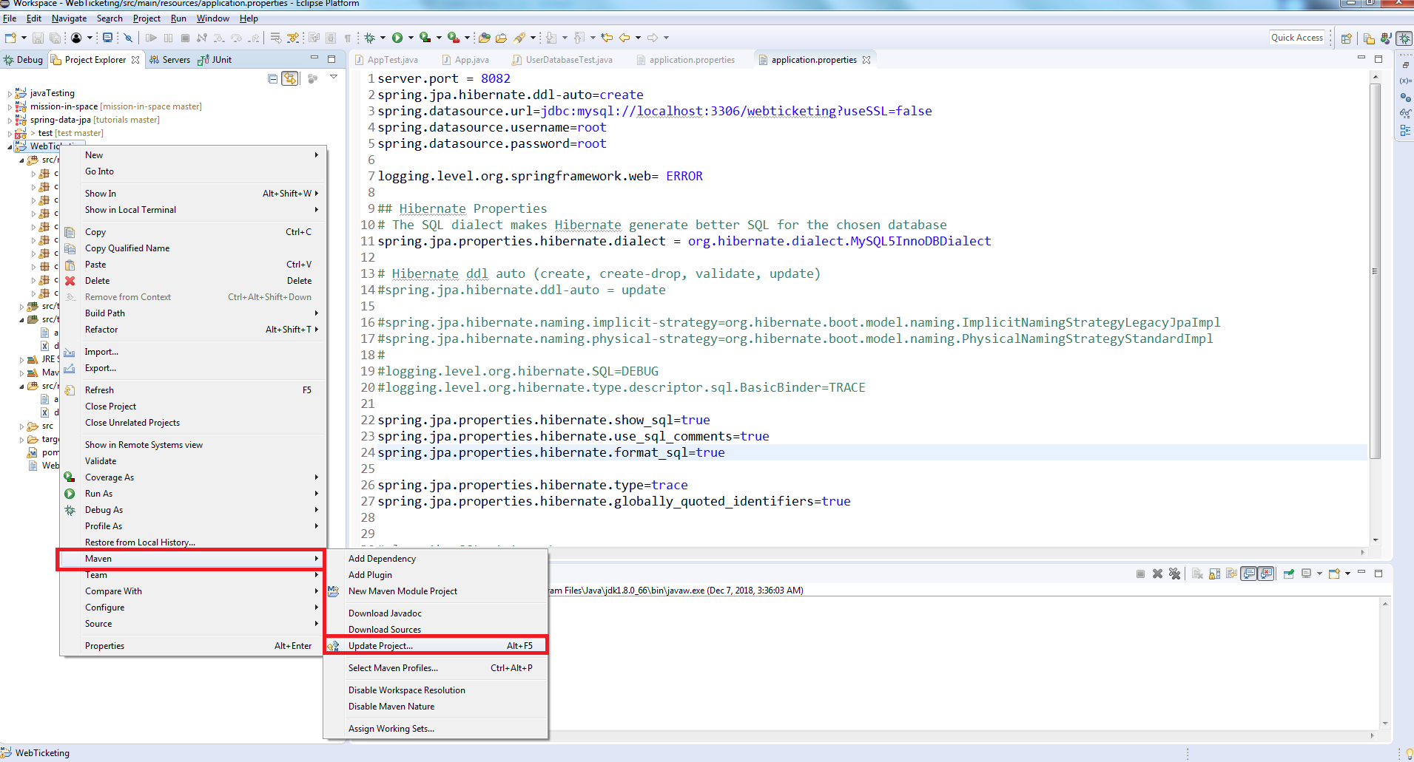

1. Make sure to check the checkbox of force update as in the below screenshot

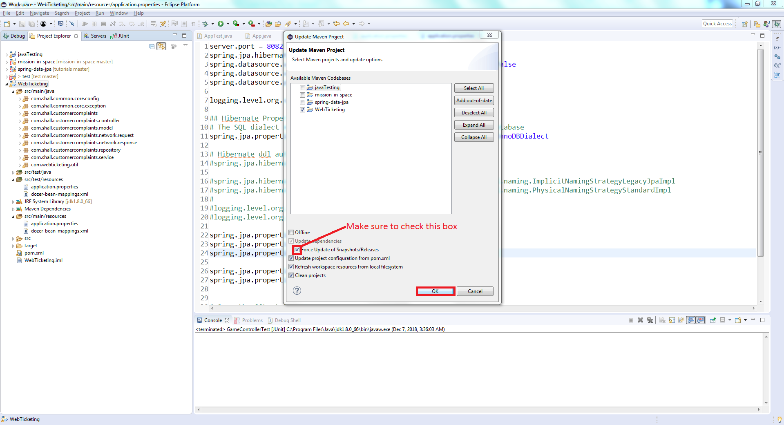

1. After this, we need to make sure that the project java version is set to the JDK, so right click on the project 🡪 Properties 🡪 Build path 🡪 Make sure that the java version there is JDK

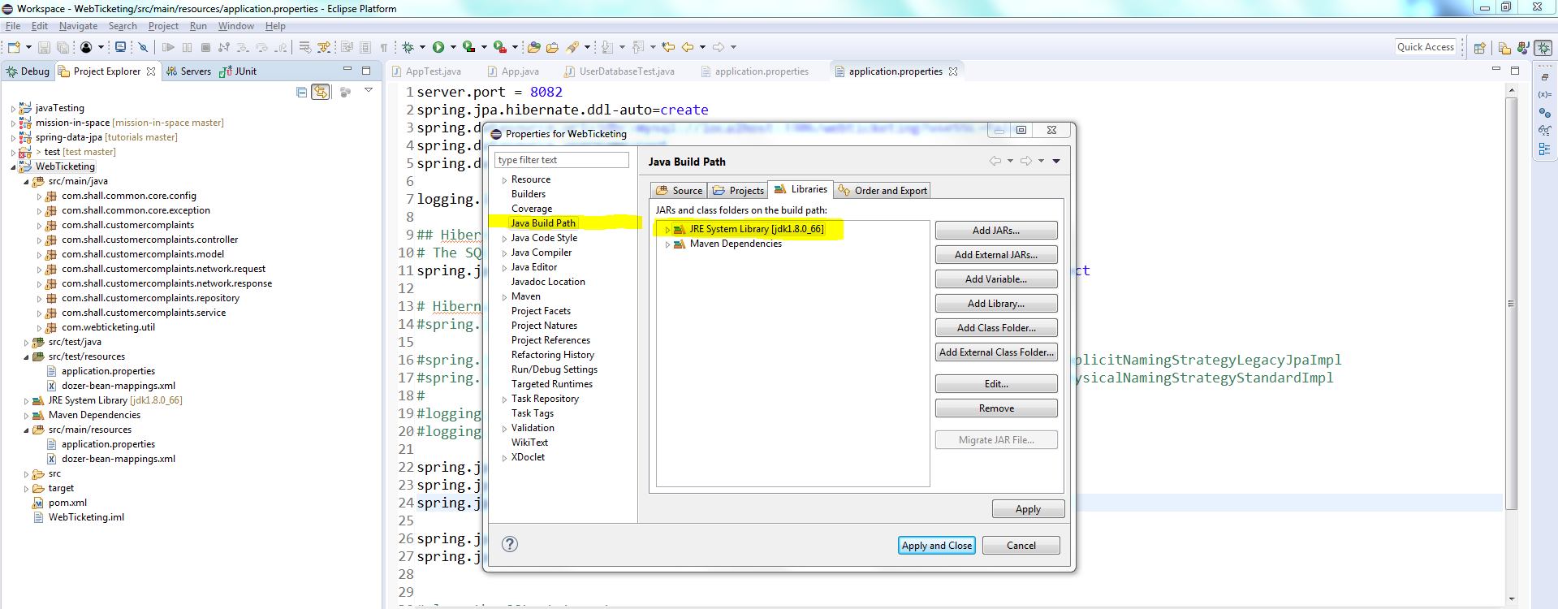

1. From the toolbar 🡪 select project 🡪 clean

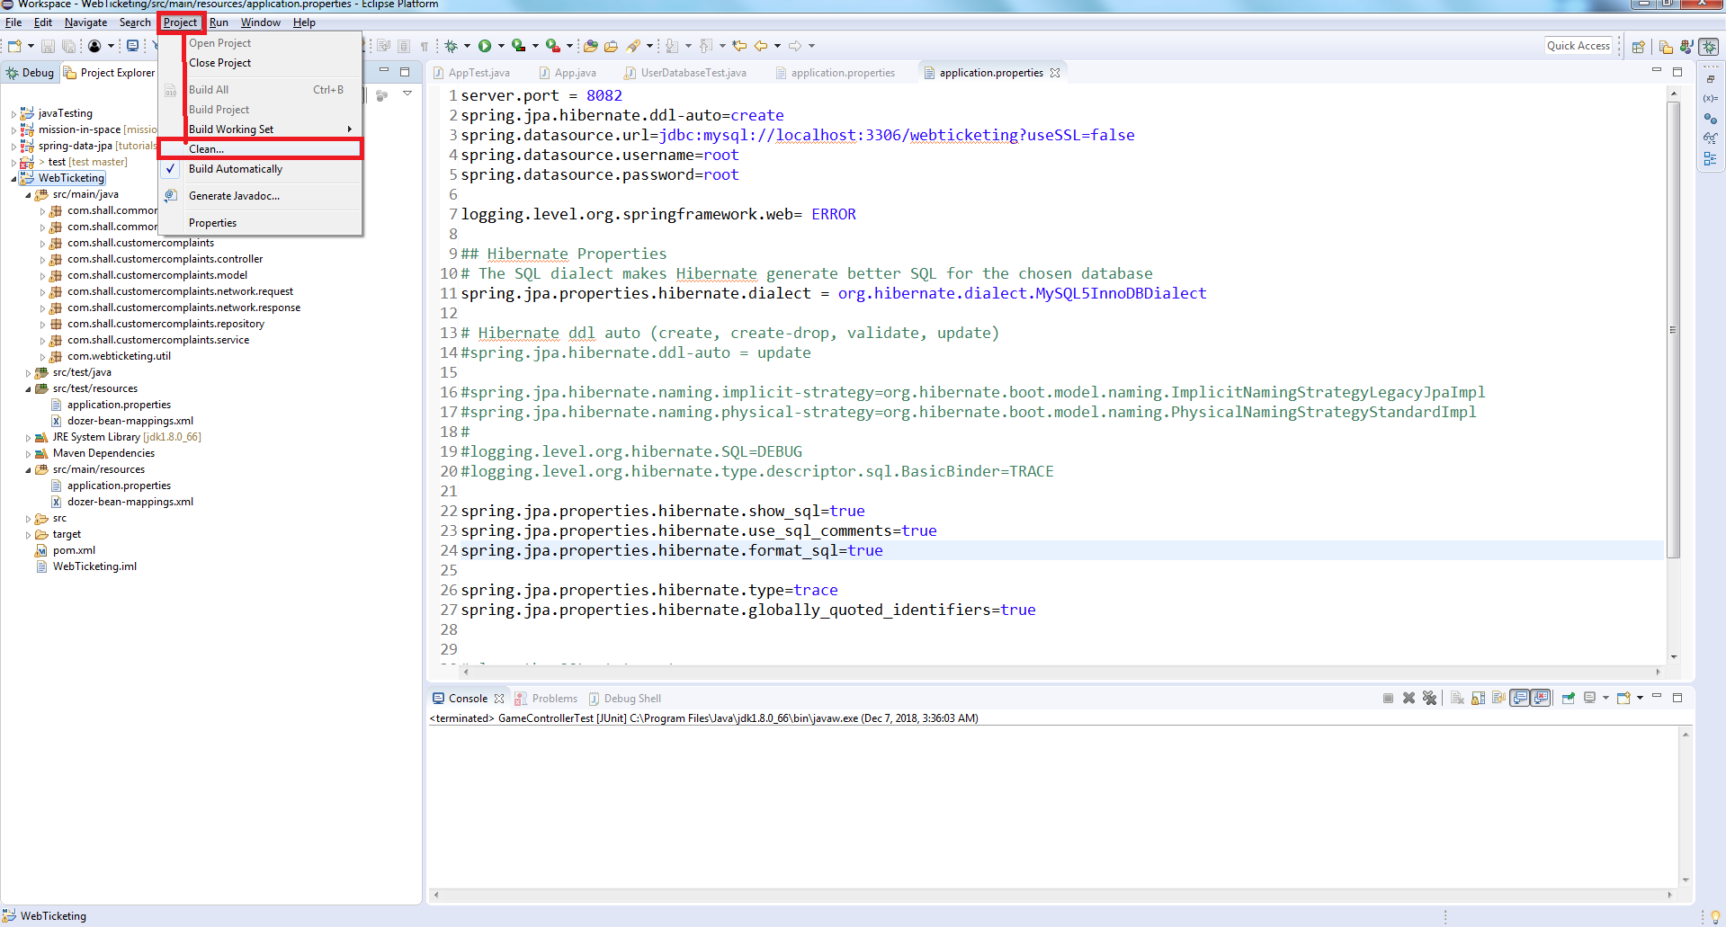

1. Now, right click on the project 🡪 Run as 🡪 Maven clean
2. Now, right click on the project 🡪 Run as 🡪 Maven install

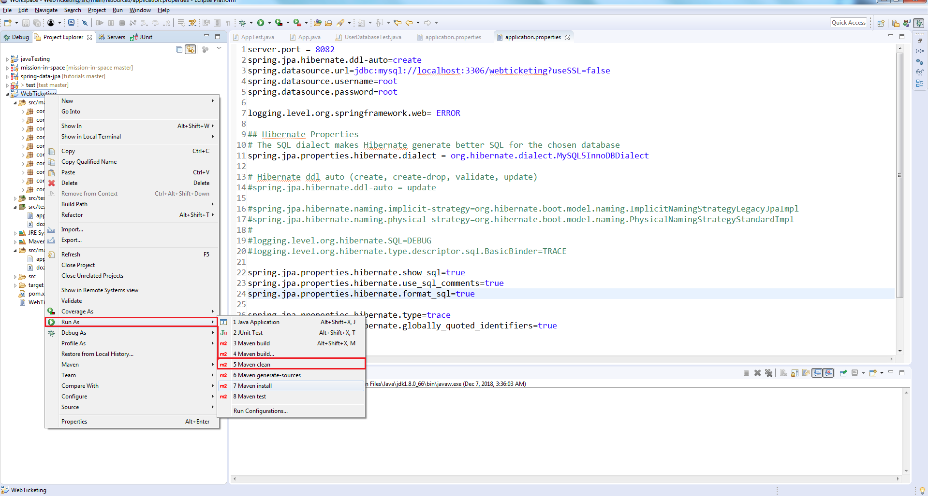

1. Wait until you see the project build as **Build Success**

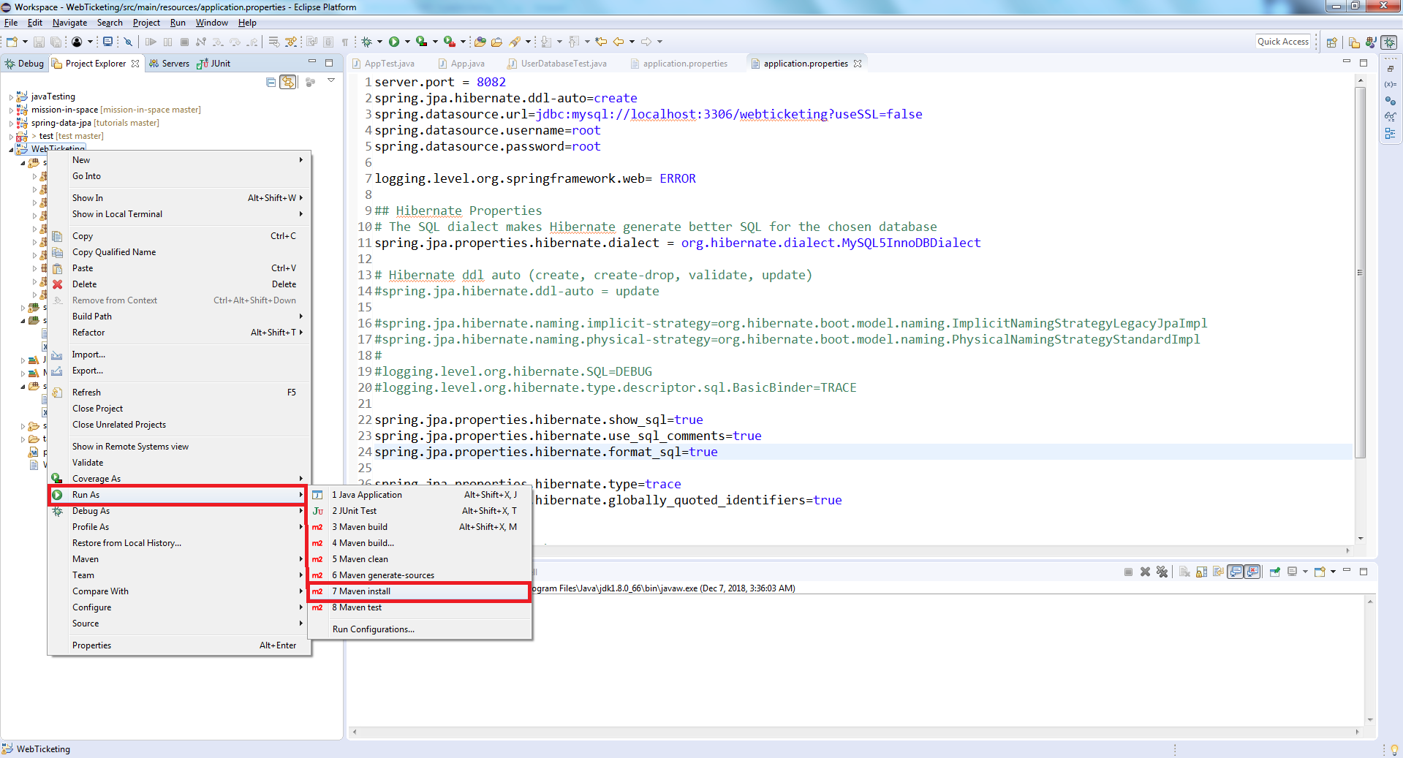

## Activity Instructions:

1. Navigate to the **AppTest** under test package com.openclassrooms.testing
2. Generate the test cases in this class for the **App** class